**PRACTICAL 5: String manipulation**

**Aim:**

To write C++ program demonstrating string manipulation

**THEORY:**

**String manipulation:** C++ stores a string as an array of characters. An array is a group of contagious memory location that can be stored same type of data. So, the string declaration is same as array declaration.

**String functions:** String functions present in the string header file are STRCMP() [String compare], STRCPY() [String copy], STRLEN() [String length], STRCAT() [String concatenate]. How these functions work will be demonstrated below in the program.

**Q1a. Find length of a string**

**CODE:**

#include <iostream>

#include <string>

using namespace std;

int main()

{

string str;

cout << "Enter a string: ";

cin >> str;

cout << str.length();

return 0;

}

**OUTPUT:**

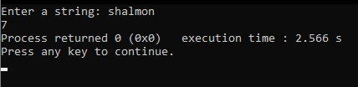

**Fig1. Output of program showing length of the given string**

**Q1b. Copy a string into another**

**CODE:**

#include <iostream>

#include <string.h>

using namespace std;

int main()

{

char str[100];

char str1[100];

cout << "Enter a string: ";

cin >> str;

strcpy (str1, str);

cout << "The copied string is: " << str1 << endl;

}

**OUTPUT:**

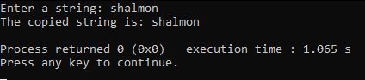

**Fig2. Output of program showing copied string**

**Q1c. Combine two strings**

**CODE:**

#include <iostream>

#include <string.h>

using namespace std;

int main()

{

char str[100];

char str1[100];

cout<<"Enter the first string: ";

cin.getline(str,100);

cout<<"Enter the second string: ";

cin.getline(str1,100);

strcat(str,str1);

cout<<"The combined string is: "<<str;

}

**OUTPUT:**

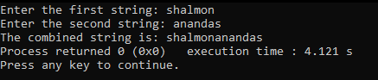

**Fig3. Output of program showing two given strings combined**

**Q1d. Compare whether entered two strings are equal**

**CODE:**

#include <iostream>

#include <string.h>

using namespace std;

int main()

{

char str1[100], str2[100];

int result;

cout << "Enter first string: ";

cin.getline(str1, 100);

cout << "Enter second string: ";

cin.getline(str2, 100);

result = strcmp(str1, str2);

switch(result)

{

case 0:

cout << "Strings are equal";

break;

case 1:

cout << "Strings are not equal";

break;

}

}

**OUTPUT:**

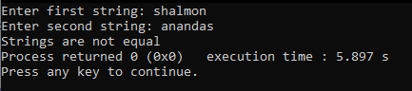

**Fig4. Output of program comparing if the two strings are equal or not**